**Smart Health Care Monitoring system using Raspberry pi**

**Himanshu Kumar , Suhail T N , Manoj more S , Suresh V**

**S. Rajarajeswari**

Department of Computer Science and Engineering,

M.S. Ramaiah Institute of Technology, Bangalore 560054, India

*Abstract*—Monitoring healthcare in current generation is to be given an utmost importance. Diseases are the brutal hurdles to human beneficiary. One amongst them is the Alzheimer’s and Quadriplegia. In order to minimize the difficulties of people who are suffering from Alzheimer or Quadriplegia, this project allows the data of a patient’s vital body parameters and movements to be collected by wearable or implantable sensors and communicated using wireless communication techniques. Monitoring the health of affected individuals are achieved by an android mobile application which shows the varying heart beat and temperature. The process involves generation of data from appropriate Sensors that are embedded on the Raspberry pi board. The data generated are sent to the server that is created using Elastic Compute Generation II Amazon Web Service and this stored data is sent to the Android Application. If the data read from the prototype is beyond the threshold value, then the patient’s relatives and the physician will be notified about the same along with his current location. This system for automated health alerts provides a method for detecting health problems very early so that early treatment is possible.

Keywords— Raspberry pi, Renesas, AWS, EC2, Android application, GPS and GPRS

# Introduction

The person suffering from Alzheimer diseases finds it difficult to remember their own location and suffer from inability to recognize common things. People suffering from Quadriplegia sometimes cannot breathe properly and during this time their heart beat may go low or they may be uncomfortable at this time. In order to minimize the difficulties of people who are suffering from Alzheimer or Quadriplegia and to keep track of their vitals is important, this project proposed a method to help to locate Alzheimer patients and Quadriplegia, when they venture outdoors. Also in the proposed project the patient health is monitored for heart monitoring and body temperature, so this data can be accessed by the android application.

# LITERATURE SURVEY

Monitoring healthcare in current generation is to be given an utmost importance. This project keeps track of Alzheimer’s and Quadriplegia patient vitals. The proposed method locates such patient and tracks vitals such has heart beat and body temperature to ensure better care of patient in critical situation. A individuals vitals are available on the android application, so that doctor and patient’s guardian can keep track of patient’s status.

***Automated Health Alerts Using In-Home Sensor Data for Embedded Health Assessment*** [12] will continuously monitor the home for the purpose of assessing early health changes. Sensors embedded in the environment capture behavior and activity patterns. The major advantage here is this method keeps track of vitals but this makes use of multiple embedded sensor which are supposed to be install at all over the home, which result in more power consumption and this implementation is expensive. Instead of installing the embedded sensors all over the home, proposed method has one embedded sensor to keep track of individual person.

***In proposed system the concept of wireless sensor network*** [13] is implemented so the patient’s vitals in available in laptop which is virtually connected to the embedded sensor board, by this setup the embedded board can be can be accessed via GUI interface and reprogrammed.

***A Smart System connecting e-Health Sensors and the Cloud*** [14] this method is using the AWS services for data storage and analytics. The proposed system uses AWS service where cloud desktop instance is created using EC2 service. In Cloud desktop instance uses the RDS service for the data storage purpose, and TCP listener application captures the data sent from the embedded board and form the data to the android application using the port number 85.

|  |  |  |  |
| --- | --- | --- | --- |
| Sl.No | Referred Paper | Cocept acquired | Usage of Concept |
| 01 | Paper1[12] | Use Sensor in Health Montioring | 20% |
| 02 | Paper2[14] | Wireless Sensor Networks using Raspberry Pi | 20% |
| 03 | Paper3[15] | Connecting Sensor and Cloud (AWS) | 20% |

Table 1 Literature Survey Summary

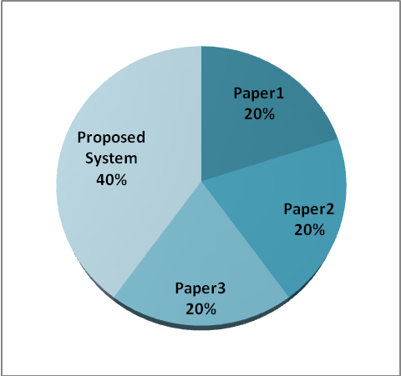

1. Chart Representation of Literature Survey

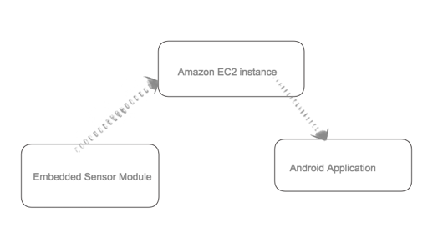

1. Working concept

In [14] the advantage was using AWS services for the storage and analytics but the data stored where not forwarded to doctor or patient guardian, but in proposed system we made use of cloud desktop server and android application so that patient real time data is available on mobile devices. A Wireless Tracking System for At-home Medical Equipment during Natural Disasters [15] described about accessing real time location of medical equipment which was again waste of resources, because method comes into picture only when natural disaster occurs. Only in order to keep track of medical equipment the power consuming method is used. But in proposed system we use the method to keep track of the patient location. The white paper of the Structured monitoring product [16] is referred has a part of proposed system future enhancement, Where the concept of the Doppler effect can be used to eliminate the physical contact of sensor with the human body, data vitals are read through the wireless connectivity.

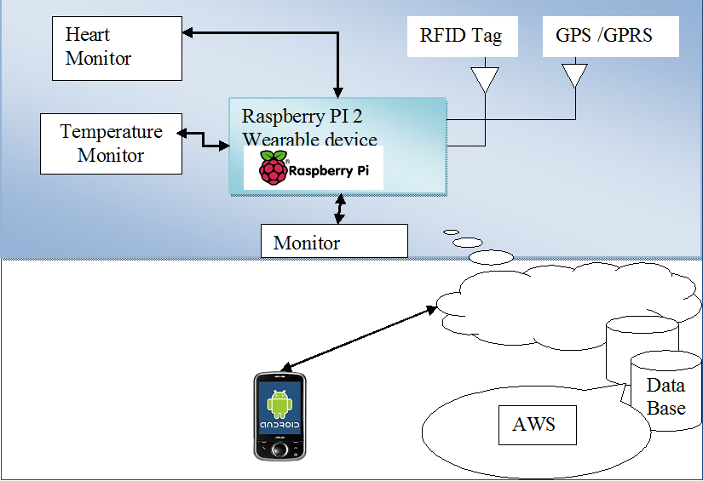

1. Proposed System design

# DESIGN

## Introduction

The different modules needed and their descriptions are given below:

*Heart Beat Sensor Module:* This module is responsible for identifying the change in heart rate, The Heart Beat Sensor provides a simple way to study the heart's function. This sensor monitors the flow of blood through Finger. As the heart forces blood through the blood vessels in the Finger, the amount of blood in the Finger changes with time. The sensor shines a light lobe (small High Bright LED) through the ear and measures the light that is transmitted to LDR. The signal is amplified, inverted and filtered, in the Circuit. Usually Heart rate will be calculated for 1Minute. For a healthy human being we get heart rate of 72 pulse rate per 1 minute. For real time applications we cannot wait for 1minute each time because if there is any disturbance in calculating for ex: if patient is not properly keep his finger inside the device means again we have to take the readings. For this we are following averaging & sampling method. In this we are calculating heart rate for each 5 seconds & we are replacing that value in array of 12 characters. After replacing each value we will add the entire array. After the 12th value we will replace the 13th value on the 1st array element so that we will get average heart rate value for 1 minute. For 5second approximately we get rating of 6 bp/5sec.

*Raspberry pi 2 model B Module:*Raspberry Pi is a mini computer which is of the size of a credit card. The operating system is called Raspbian OS which is simple and is optimized for Raspberry pi. It’s an open source operating system based on Debian. Once the operating system has been loaded in the Raspberry Pi using the SD card which is of class 10 or higher. The Raspberry pi 2 it has A 900mhz quad-core Arm cortex-a7 CPU, 1gb Ram, 4 USB ports, GPIO 40 pins, Full HDMI port, Ethernet port, combined 3.5mm audio jack and composite video, Camera interface (CSI), Display interface (DSI), Micro SD card slot, Video core 1v3d graphics core.

*Temperature Sensing Module (LM35):*The LM35 series are precision integrated-circuit temperature sensors, whose output voltage is linearly proportional to the Celsius (Centigrade) temperature. The LM35 thus has an advantage over linear temperature sensors calibrated in Kelvin, as the user is not required to subtract a large constant voltage from its output to obtain convenient Centigrade scaling. The LM35 does not require any external calibration or trimming to provide typical accuracies of ±1⁄4˚C at room temperature and ±3⁄4˚C over a full −55 to +150˚C temperature range. Low cost is assured by trimming and calibration at the water level. The LM35’s low output impedance, linear output, and precise inherent calibration make interfacing to readout or control circuitry especially easy. It can be used with single power supplies, or with plus and minus supplies. As it draws only 60 µA from its supply, it has very low self-heating, less than 0.1˚C in still air. The LM35 is rated to operate over a −55˚ to +150˚C temperature range.

*RFID Module:*Radio-frequency identification (RFID) is an automatic identification method, relying on storing and remotely retrieving data using devices called RFID tags or transponders. The technology requires some extent of cooperation of an RFID reader and an RFID tag. Radio frequency identification (RFID) technology has been in use for several decades to track and identify goods, assets and even living things. Recently, however, RFID has generated widespread corporate interest as a means to improve supply chain performance. Market activity has been exploding since Wal-Mart's June 2003 announcement that its top 100 suppliers must be RFID-compliant by January 2005. Mandates from Wal-Mart and the Department of Defense (DoD) are making many companies scramble to evaluate, select and implement solutions that will make them compliant with their customers' RFID requirements and additional retailers and other large supply chain channel masters are likely to follow suit.

*GSM Module:* Global System for Mobile communications (GSM: originally from Grouped Special Mobile) is the most popular standard for mobile phones in the world. Its promoter, the GSM Association, estimates that 82% of the global mobile market uses the standard. GSM is used by over 3 billion people across more than 212 countries and territories. Its ubiquity makes international roaming very common between mobile phone operators, enabling subscribers to use their phones in many parts of the world. GSM differs from its predecessors in that both signaling and speech channels are digital, and thus is considered a second generation (2G) mobile phone system. This has also meant that data communication was easy to build into the system.

*GPRS Module***:** General Packet Radio Services is a packet-based wireless communication service that promises data rates from 56 up to 114 Kbps and continuous connection to the Internet for mobile phone and computer users.

*Database Module:* This module’s function is to insert the data into the Android Application and provide persistent storage for all the activities performed by the user and will be helpful when the user/doctor needs to monitor the user’s activities.

*Web Services (AWS)**:* AWS IoT is a platform that enables you to connect devices to AWS Services and other devices, secure data and interactions, process and act upon device data, and enable applications to interact with devices even when they are offline.

*Android Application Module:* This module’s function is to display the Data generated from the various Sensors that are connected to Raspberry pi. Different data such as Heart rate, temperature, location and User unique RFID is are taken into consideration and are notified to the guardian and Doctor. Basically this module gives the overall status of the patient to the intended person.

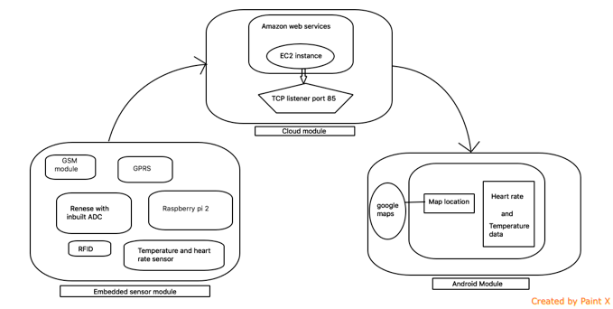

1. System Architecture

. The system architecture helps in designing the UML diagrams like the Class diagram, Sequence Diagram and Data flow diagram.

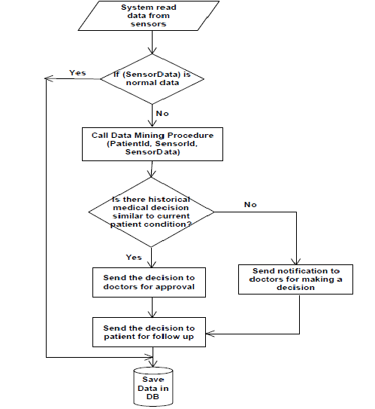

1. Flow Diagram

## Class Diagram

The relationship among various classes and their interdependencies are effectively modeled and designed using the class diagram with the help of association, aggregation, composition and generalization which is shown in Fig. 6.

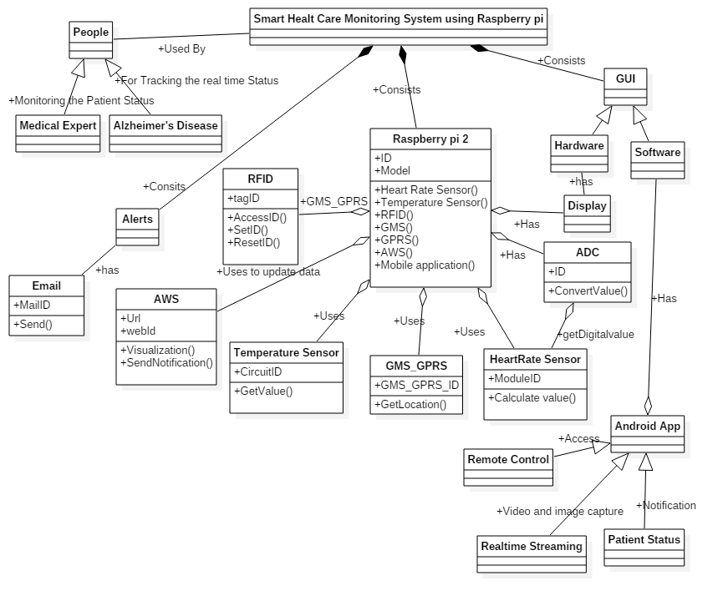

1. Class Diagram

## Sequence Diagram

The sequence diagrams for this project are given in Fig. 7,Fig. 8 and Fig. 9. These are helpful in designing the order of occurrence of events and the corresponding actions that needs to be performed.

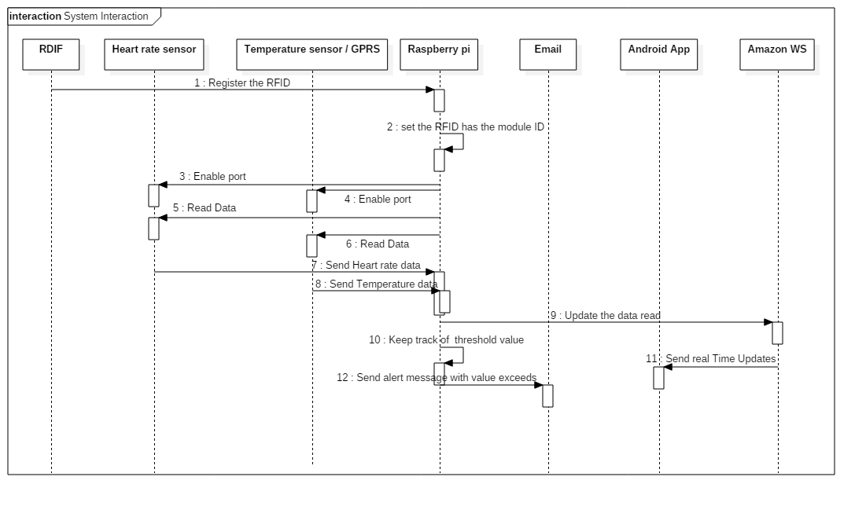

1. Sequence Diagram for the Overall System

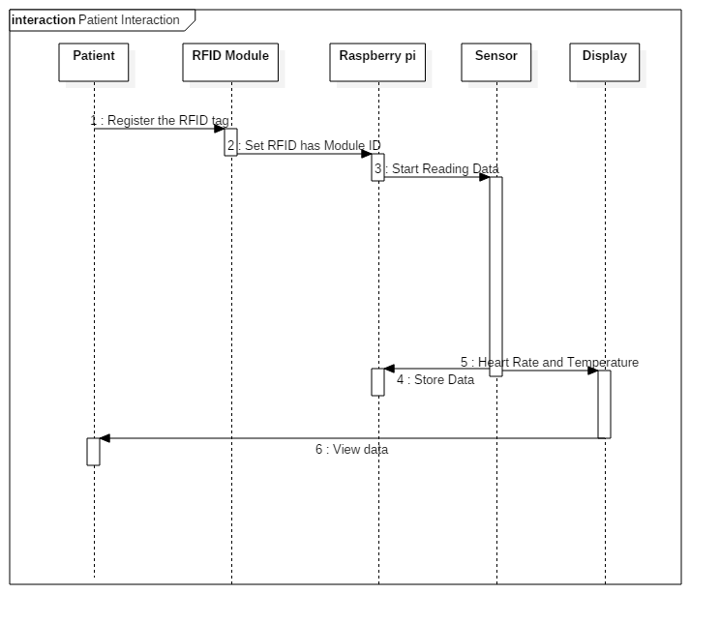

1. Sequence Diagram for the Patient action

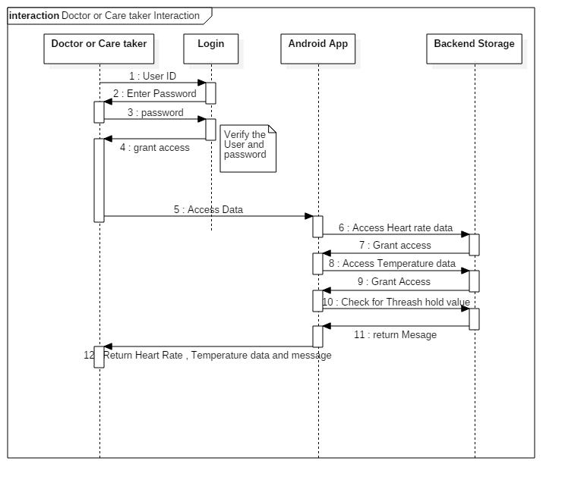

1. Sequence Diagram for Doctor/Care taker interaction

## Data Flow Diagram

The data flow diagram is responsible for depicting the flow of data among the various entities and modules in the system. Proposed method begins with RFID module, once RFID content is read the GPRS initialization starts and then the sensor data are gathered together. Collected data is sent to EC2 instance that is created using AWS.The same real time data is available over android application. It is shown in Figure 10.

Untitled Diagram1.png

1. Data Flow Diagram

# IMPLEMENTATION

Embedded module implementation takes place by interfacing the reneses and raspberry pi board. Reneses will have the inbuilt ADC so the temperature data is obtained from the reneses after ADC conversion. Circuit diagram for the embedded module is shown in figure 4.1.Once the hardware connection is made, make sure hardware module and laptop both are connected to the same shared network. Use angry IP scanner to get the IP of raspberry pi module. Raspberry pi is access with putty terminal and with the VNC server for GUI access. VNC server is used to give the UI interface to the raspberry pi module, UI can be accessed by using raspberry pi IP.AWS Ec2 service used in order have the cloud server, used to divert the data to android application.



1. complete hard ware implementation

## **Algorithm and Implementation Details**

This algorithm deals with the hardware aspects of the project.

Input: Raspberry Pi with all the Sensor connections.

Output: Updating Heart Rate Sensor values and Temperature value to AWS and Android Application Module, sending Email Alert.

1. R 🡨 Raw data from the Heart Rate sensors.

2. Ra 🡨 P (R) // parsing the raw data to obtain the actual analog voltage values.

3.Rd 🡨 ADC (Ra) //Converting to digital voltage value.

Monitor (Rd) /* Displaying appropriate messages and digitalvoltage value on Monitor. */

4.App 🡨 Rd // Send data to Android Application.

5.Loop (Keep Track of Threshold value Being Sensed)

6.Send Notification Alert.

7.Send Email Alert using phone’s Internet with location as attachment.

Buzzer 🡨 ON

8.If (Temperature Exceeds)

Variable1 🡨 Store Time, Date and Location.

Wc++

9..Else IF (Heart Rate Data Exceeds)

Variable2🡨 Store Time, Date and Location.

Wc++

10.Loop back to step 1.

# TESTING AND RESULTS

Introduction **:**

*Pairing to GSM Module and Transfer data (Using Flash magic):*Software called Flash Magic can be used to test the GMS module. By shorting the Rx and Tx pins i.e. the receiver and the transmitter pins GSM, the message that is sent is delivered to destination server refer table 2.

|  |  |
| --- | --- |
| **Test Case ID.** | 1 |
| **Test Case Objective** | Connect to device |
| **Execution steps** | Execute Connection command |
| **Test Input** | NA |
| **Expected Output** | Device Paired |
| **Passed(?)** | Yes |

Table 2 Unit Test Case 1

*Test GPRS*

Setup GPRS and verify the same with current location Latitude and Longitude. Once the Latitude, Longitude value is available on the android application. Cross check the location by clicking on the map button added in application, refer table 3.

|  |  |
| --- | --- |
| **Test Case ID.** | 2 |
| **Test Case Objective** | Check GPRS Location,Latitude,Longitude |
| **Execution steps** | Execute the code |
| **Test Input** | Power supply, GPRS signal. |
| **Expected Output** | If signal available, Output latitude, longitude. Check the map in android app |
| **Passed(?)** | Yes |

Table 3 Unit Test Case 2

Raise and fall in heart rate data over the

variation in the pulse count refer table 4.

|  |  |
| --- | --- |
| **Test Case ID.** | 3 |
| **Test Case Objective** | Identify the variation in heart beat |
| **Execution steps** | Place your thumb finger inside heart rate sensor |
| **Test Input** | Varying Pulse count |
| **Expected Output** | Rise and fall in heart rate |
| **Passed(?)** | Yes |

Table 4 Unit Test Case 3

# CONCLUSION

The integration between wireless sensor networks and cloud computing will create a new generation of technology in many aspects such as patient monitoring with minimal cost, health alerts, etc. The system that is proposed is light weight so that it can be used on a daily basis and will help in quick recovery. The system presents an approach for Alzheimer patient tracking using the RFID tags and the GPS. System can detect and build accurate maps and can send it to the desired people during an emergency. Along with all the other features, the system also monitors the temperature and heartbeat of the patient. By sending an Email alert to the doctor and care taker along with the GPS position of the user it ensures that the user receives immediate care.

Further this functionality can be extended to monitor various other parameter of the patient by including other sensors. The concept of radio Doppler Effect can be used to read the patient vitals in the wireless mode so that just by making use of radio wave the data can be read

##### References

[1] [online] <http://www.centrenational-rfid.com>.

[2] [online] www.alzfdn.org

[3] [online] http//www. arduino.cc/

[4] [online] <http://structuredmp.com/index.html>

[5] [online] www.livescience.com

[6] [online] www.medindia.net

[7] [online] www.modsci.org

[8] [online] [www.amazon.com/ec2](http://www.amazon.com/ec2)

[9] [online] [www.amazon.com/rds](http://www.amazon.com/rds)

[10] [online] www.mayoclinic.org

[11] [online]www.hopkinsmedicine.org

[12] Skubic, M., Guevara, R. D., & Rantz, M. (2015). Automated health alerts using in-home sensor data for embedded health assessment. *Translational Engineering in Health and Medicine, IEEE Journal of*, *3*, 1-11.

[13] Nikhade, S. G. (2015, May). Wireless sensor network system using Raspberry Pi and ZigBee for environmental monitoring applications. In *Smart Technologies and Management for Computing, Communication, Controls, Energy and Materials (ICSTM), 2015 International Conference on* (pp. 376-381). IEEE.

[14] Jassas, M. S., Qasem, A. A., & Mahmoud, Q. H. (2015, May). A smart system connecting e-health sensors and the cloud. In *Electrical and Computer Engineering (CCECE), 2015 IEEE 28th Canadian Conference on*(pp. 712-716). IEEE.

[15] Li, D. (2015, May). A wireless tracking system for at-home medical equipment during natural disasters. In *Systems, Applications and Technology Conference (LISAT), 2015 IEEE Long Island* (pp. 1-6). IEEE.

[16] Finkenzeller, K., & Handbook, R. F. I. D. (1999). Radio-frequency identification fundamentals and applications. *Chippenham: John Wiley & Son*.

[17] Budiharto, W. (2014, August). Design of tracked robot with remote control for surveillance. In *Advanced Mechatronic Systems (ICAMechS), 2014 International Conference on* (pp. 342-346). IEEE.

[18] Lymberis, A. (2003, April). Smart wearables for remote health monitoring, from prevention to rehabilitation: current R&D, future challenges. In*Information Technology Applications in Biomedicine, 2003. 4th International IEEE EMBS Special Topic Conference on* (pp. 272-275). IEEE.

[19] Warren, S., Craft, R. L., & Bosma, B. (1999, April). Designing smart health care technology into the home of the future. In *Workshops on Future Medical Devices: Home Care Technologies for the 21st Century* (Vol. 2, p. 667).